Sunday | Monday | Tuesday | Wednesday | Thursday | Friday | Saturday
December 2017 Halifax Bridge World  www.halifaxbridgeworld.com 902-454-4098 | 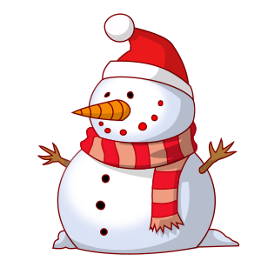 | 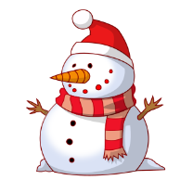 |  |  | 1  Strat Open  Pairs A/B/C  9:15 | 2  Strat Pairs  A/B/C 12:30
3 | 4 STAC Strat Open Pairs  A/B/C 9:15  Gentle Duplicate  0-100 12:45 | 5  STAC Pairs  A/B/C 12:30  0-300 Strat Pairs  A/B/C 6:30 pm | 6 STAC  “A” & “C” Team Game 12:30  STAC Strat Open Pairs A/B/C 7pm | 7 Super Play 9:30  0-1500 STAC Pairs  A/B/C 12:30  STAC Where’s Waldo  A/B/C Pairs 7pm | 8  STAC Strat Open  Pairs A/B/C  9:15 | 9  STAC Pairs  A/B/C 12:30
10 Turkey  Team Game  Game time 9:30!  2 sessions with  Turkey Dinner  STAC game! | 11 COPC Strat Open Pairs  A/B/C 9:15  Gentle Duplicate  C.C. 0-100 12:45 | 12  Happy Hanukkah!  COPC Pairs 12:30  0-300 Strat Pairs  A/B/C 6:30 pm | 13  “A” & “C” C.C.  Team Game 12:30  COPC Strat Open Pairs A/B/C 7pm | 14 Super Play 9:30  0-1500 Strat C.C. Pairs A/B/C 12:30  Where’s Waldo  A/B/C Pairs 7pm | 15  COPC  Strat Open  Pairs A/B/C  9:15 | 16  Happy Birthday  COPC Pairs  A/B/C 12:30
17  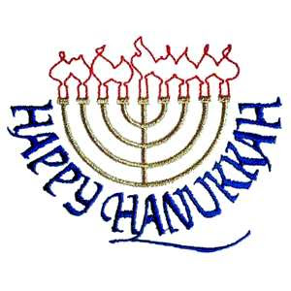 | 18 C.C. Strat  Open Pairs  A/B/C 9:15  Gentle Duplicate  0-100 12:45 | 19  COPC Pairs  A/B/C 12:30  0-300 C.C Strat Prs A/B/C 6:30  A/B/C 6:30 | 20  “A” & “C” Team Game 12:30  Int’l Fund Game Prs A/B/C 7pm | 21 Super Play 9:30  0-1500 Strat Pairs  A/B/C 12:30  Where’s Waldo C.C.  A/B/C Pairs 7pm | 22  C.C.  Strat Open  Pairs A/B/C  9:15 | 23  COPC Pairs  A/B/C 12:30
24  C.C. stands for  Club Championship | 25 | 26  The Only Boxing Day Game for all!  C.C Strat A/B/C  Game time 12:30 | 27  “A” & “C” Team Game 12:30  COPC Strat Open Pairs A/B/C 7pm | 28 Super Play 9:30  0-1500 Strat Pairs  A/B/C 12:30  Where’s Waldo  A/B/C Pairs 7pm | 29  COPC  Strat Open  Pairs A/B/C  9:15 | 30  COPC Pairs  A/B/C 12:30
Sunday evening December 31st. Join in the fun at HBW starting with a Pot Luck dinner at 6:30 pm followed by a stratified Club Championship pairs game for bridge players of all levels. Sign up at the club.

