Sunday | Monday | Tuesday | Wednesday | Thursday | Friday | Saturday
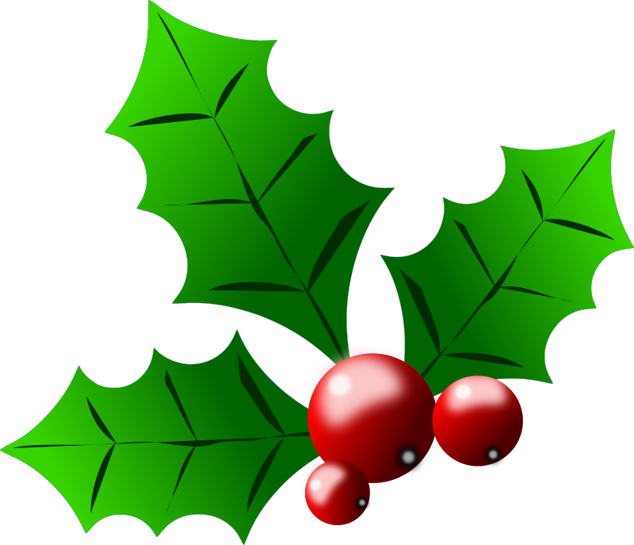 Halifax Bridge World  December 2016 902-454-4098  www.halifaxbridgeworld.com |  |  |  | 1 Supervised Play  9:30 am  0-1000 Strat Pairs  A/B/C 12:30  Where’s Waldo  Strat Pairs 7 pm | 2  Strat Open  Pairs  9:15 am | 3  Strat Open Pairs A/B/C 12:30
4 Student  Graduation  Game and Party 1pm | 5 Strat Open Pairs  A/B/C 9:15 am  Gentle Duplicate  C.C. 0-99 12:30  Strat Open Pairs  A/B/C 7 pm | 6 C.C. Strat Open Prs A/B/C Only $5 12:30 pm  0-300 Strat Prs  A/B/C 6:30 pm | 7  CNTC Team Game  12:30  Strat Open Pairs  COPC 7 pm | 8 Supervised Play  9:30 am  0-1000 Strat Pairs  A B C 12:30  Where’s Waldo  Strat Pairs 7 pm | 9  C.C. Strat  Open Pairs A/B/C  9:15 am | 10 Turkey Bowl  2 session  C.C.Teams  with Dinner  9:30 am start
11  C.C. stands for Club Championship Games. Our treat to you for this festive holiday season! | 12 COPC Strat Open Prs 9:15 am  0-300 Holiday C.C. Ham Dinner  Dinner 5:30  Bridge 6:30  Gentle Duplicate  0-99ers 12:30  Strat C.C. Open Pairs A/B/C 7 pm | 13 COPC Strat Prs A/B/C 12:30 | 14  CNTC Team Game  12:30  Strat Open Pairs  COPC 7 pm | 15 Supervised Play  9:30 am  C.C. 0-1000 Strat  Prs A/B/C 12:30  Where’s Waldo  Strat Pairs 7 pm | 16  Strat Open  Pairs  A/B/C  9:15 am | 17  Happy Birthday  Strat Open Pairs A/B/C 12:30
18. | 19 C.C. Strat Open Prs A/B/C 9:15 am  Gentle Duplicate  0-99 12:30  COPC Strat Open Pairs A/B/C 7 pm 7 pm | 20 COPC Strat Open Prs A/B/C Only $6 12:30 pm  0-300 Strat Prs  A/B/C 6:30 pm | 21  CNTC Team Game  12:30  Strat Open Pairs  C.C. 7 pm | 22 Supervised Play  9:30 am  0-1000 Strat Pairs  A/B/C 12:30  C.C.Where’s Waldo  Strat Pairs 7 pm | 23  COPC Strat Open  Pairs  A/B/C  9:15 am | 24  Merry Christmas!  Strat Open Pairs A/B/C 12:30
25 | 26  Happy Boxing Day | 27 COPC Strat Open Prs A/B/C Only $6 12:30 pm  0-300 Strat Prs  A/B/C 6:30 pm | 28  CNTC Team Game  12:30  Strat Open Pairs  COPC 7 pm | 29 Supervised Play  9:30 am  0-1000 Strat Pairs  A/B/C 12:30  Where’s Waldo  Strat Pairs 7 pm | 30  Upgraded C.C.  Strat Open  Pairs  A/B/C  9:15 am | 31 “Happy New Year”  Potluck C.C. Strat Open Pairs A/B/C  Potluck 6:30 pm  Bridge 7’ish pm  Sign up at the club!

