Sunday | Monday | Tuesday | Wednesday | Thursday | Friday |  | Saturday
May 2017 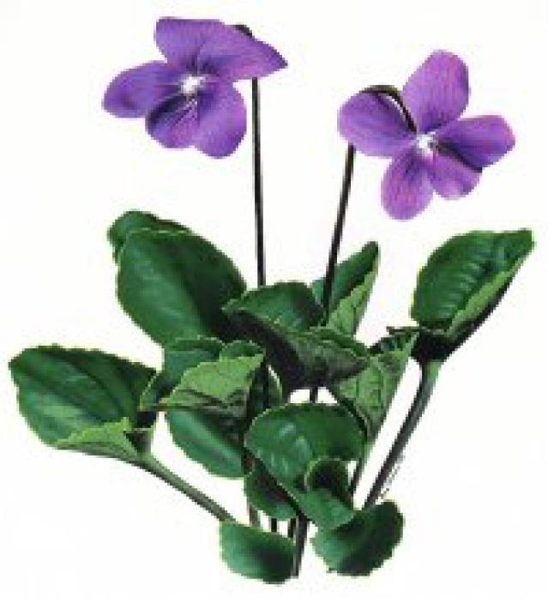 Halifax Bridge World 902-454-4098  Your Itinerary  Thursday, May 25, 2017  WS 229 7:35 am 10:04 am 05h 29m  WestJet Halifax (YHZ) Calgary (YYC) 73H Economy  Halifax Calgary (Non-stop)  Airline Confirmation #: NYXSCQ  Seating: Unless specified below, some of your seating has not been assigned.  WS 287 12:00 pm 12:26 pm 01h 26m  WestJet Calgary (YYC) Vancouver (YVR) 73H Economy  Calgary Vancouver (Non-stop)  Airline Confirmation #: NYXSCQ  Seating: Unless specified below, some of your seating has not been assigned.  Tuesday, May 30, 2017  WS 714 1:15 pm 8:45 pm 04h 30m  WestJet Vancouver (YVR) Toronto (YYZ) 73H Economy  Vancouver Toronto Int'l Airport (Non-stop)  Airline Confirmation #: NYXSCQ  Seating: Unless specified below, some of your seating has not been assigned.  WS 254 9:30 pm 12:33 am (May 31) 02h 03m  WestJet Toronto (YYZ) Halifax (YHZ) 73W Economy  Toronto Int'l Airport Halifax (Non-stop)  Airline Confirmation #: NYXSCQ  Seating: Unless specified below, some of your seating has not been assigned.  Flight and Traveller Summary  MS LINDA SUSAN TUFF 3,375 reward miles  $140.81 Taxes & Fees  Email ltuff@hotmail.com Address: 249 FIRST LAKE DRIVE LOWER SACKVILLE, CANADA B4C 3J9 Special Assistance None Canada Air Security Charge $14.25 Airport Improvement Fee $49.00 Airline Surcharges 2 $46.00 GST $1.00 HST $15.56 Booking Fee $15.00  Reward Miles 3,375  Taxes & Fees $140.81  902-454-4098 | 1. (GR) Strat Open Pairs A/B/C 9:15  Gentle Duplicate  A/B/C 12:45  (GR) Strat Open  Pairs A/B/C 7 pm | 2  Bargain Tuesday  (GR) Strat Open Prs A/B/C 12:30  0-300 Strat Pairs  A/B/C 6:30 pm | 3  (GR) Team Game 12:30 pm  (GR) Strat Open Pairs A/B/C 7pm | 4 Supervised Play  9:30 – 11:30  (GR) 0-1500 Strat  Open Pairs 12:30  Where’s Waldo  Open Pairs 7pm |  | 5  (GR) Strat Open Prs A/B/C 9:15 | 6  (GR) Strat Open Pairs A/B/C  12:30
7  (Grass Roots)  0-500 NLM  Team Game  1 Session  12:30 pm | 8 (GR) Strat Open Pairs A/B/C 9:15  Gentle Duplicate  A/B/C 12:45  (GR) Strat Open  Pairs A/B/C 7 pm | 9  Bargain Tuesday  (GR) Strat Open Prs A/B/C 12:30  (GR) 0-300 Strat  Prs A/B/C 6:30 pm | 10  (GR) Team Game 12:30 pm  (GR) Strat Open Pairs A/B/C 7pm | 11 Supervised Play  9:30 – 11:30  0-1500 Strat  Open Pairs 12:30  (GR)Where’s Waldo  Open Pairs 7pm |  | 12  (GR) Strat Open Prs A/B/C 9:15  Grass Roots Wine & Cheese 6:30 pm Strat Prs at 7 pm | 13  Happy Birthday  (GR) Strat Open Pairs A/B/C  12:30
14 | 15 (GR) Strat Open Pairs A/B/C 9:15  Gentle Duplicate  A/B/C 12:45  (GR) Strat Open  Prs A/B/C 7 pm | 16  Bargain Tuesday  (GR) Strat Open Prs A/B/C 12:30  0-300 Strat Pairs  A/B/C 6:30 pm | 17  (GR) Team Game 12:30 pm  (GR) Strat Open Pairs A/B/C 7pm | 18 Supervised Play  9:30 – 11:30  (GR) 0-1500 Strat  Open Pairs 12:30  Where’s Waldo  Open Pairs 7pm |  | 19  (GR) Strat Open Pairs A/B/C 9:15 | 20  (GR) Strat Open Pairs A/B/C  12:30
21  Mayflowers | 22 (GR) Strat Open Pairs A/B/C 9:15  Gentle Duplicate  A/B/C 12:45  (GR) Strat Open  Prs A/B/C 7 pm | 23  Bargain Tuesday  (GR) Strat Open Prs A/B/C 12:30  (GR) 0-300 Strat  Prs A/B/C 6:30 | 24  (GR) Team Game 12:30 pm  (GR) Strat Open Pairs A/B/C 7pm | 25 Supervised Play  9:30 – 11:30  0-1500 Strat  Open Pairs 12:30  (GR)Where’s Waldo  Open Pairs 7pm |  | 26  Strat Open Pairs  A/B/C 9:15  Bridgewater  Sectional at the  Best Western! | 27 Lesson 10 am then:  Closed for the Bridgewater  Sectional at the  Best Western!
28  Bridgewater  Sectional at the  Best Western! | 29 (GR) Strat Open Pairs A/B/C 9:15  Gentle Duplicate  A/B/C 12:45  (GR) Strat Open  Prs A/B/C 7 pm | 30  Bargain Tuesday  (GR) Strat Open Prs A/B/C 12:30  0-300 Strat Pairs  A/B/C 6:30 pm | 31  (GR) Team Game 12:30 pm  (GR) Strat Open Pairs A/B/C 7pm | Grass Roots (GR) FUN’d Games – all month long! Monies raised go to the Distrct 1 fund to help subsidize winners of the local NAP and GNT finals. That could be you (GR) games extra point games!

