Sunday | Monday | Tuesday | Wednesday | Thursday  6. Special Day!  50% off your 2nd game. Strat Open Pairs at 9:15 am followed by Canada Wide Olympiad Game at 12:30  $15 for the day! | Friday | Saturday
1 Annual General Meeting 12 noon  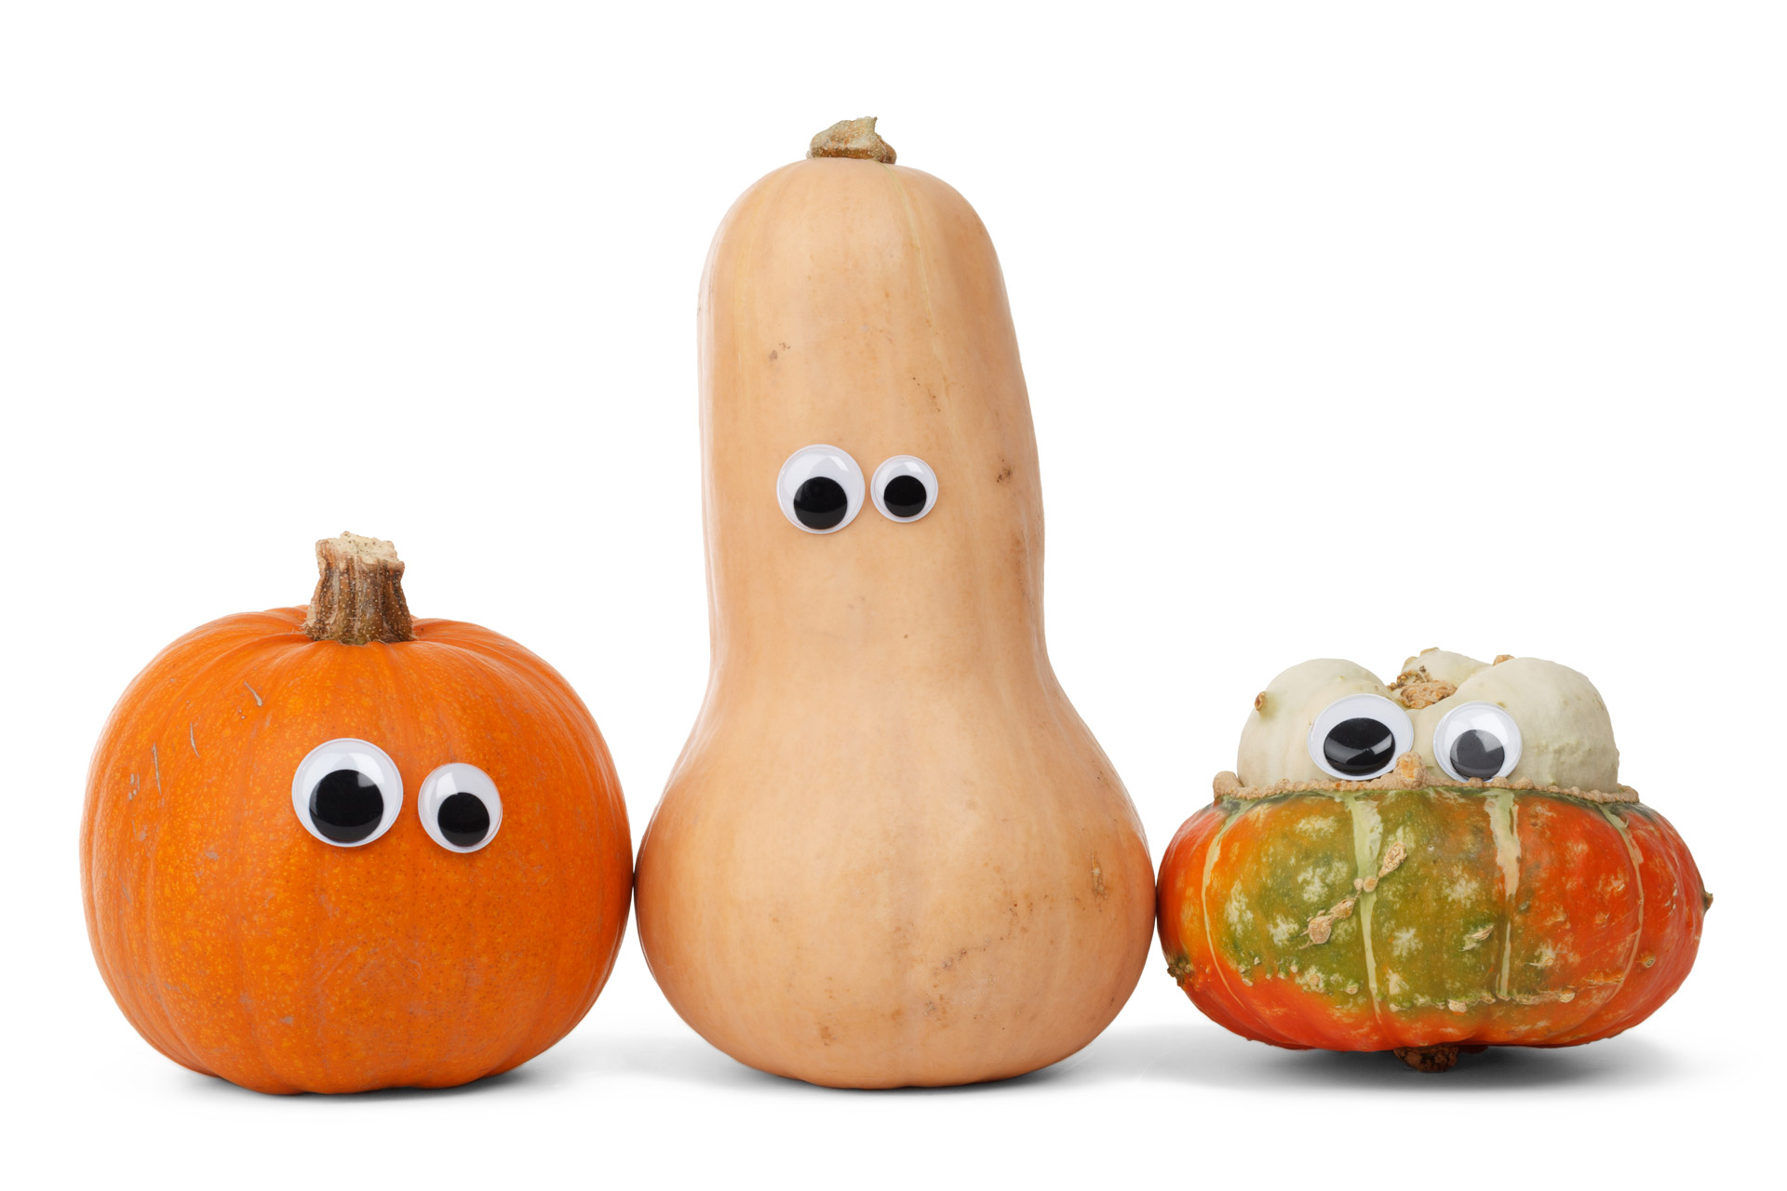  Club Appreciation Strat Open Pairs afterwards. FREE  for members | 2 Strat Open Pairs  A/B/C 9:15  Gentle Duplicate  0-100 12:45  Beginner Lesson  #1 7 – 8:30 pm | 3 Club Apprec.  Bargain Day Prs  A/B/C 12:30  0-300 Strat Prs  A/B/C 6:30pm | 4  “A” & “C” Team Game 12:30  COPC Strat Open Prs A/B/C 7pm | 5 Supervised Play 9:30  0-1500 Strat Pairs  A/B/C 12:30  Where’s Waldo  A/B/C Pairs 7pm |  | 7  COPC  Strat Open  Pairs  12:30
8  October 2017 Halifax Bridge World 902-454-4098  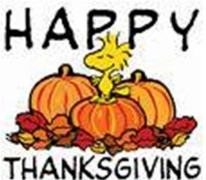 | 9 C/A Strat Open Prs A/B/C 9:15  Gentle Duplicate  0-100 12:45  Beginner Lesson  #2 7 – 8:30 pm | 10  Club Appr. Prs  A/B/C 12:30  0-300 Strat Prs  A/B/C 6:30pm | 11  Club Appr Team Game 12:30  COPC Strat Open Prs A/B/C 7pm | 12 Supervised Play 9:30  0-1500 Strat Pairs  A/B/C 12:30  Where’s Waldo  A/B/C Pairs 7pm | 13. COPC  Strat Open  Pairs 9:15 | 14. COPC Strat Open Pairs 12:30
15.
2 Section Flighted Team Games
0-500/NLM & Open Club
Appreciation GOLD DUST
12:30 start
Apple-palooza!
 | 16 Strat Open Pairs  A/B/C 9:15  Gentle Duplicate  0-100 12:45  Beginner Lesson  #3 7 – 8:30 pm | 17  COPC Pairs  A/B/C 12:30  0-300 Strat Prs  A/B/C 6:30pm | 18 “A” & “C” Team Game 12:30  Erin Berry Rookie/Master  Game 7 pm | 19 Supervised Play 9:30  C/A 0-1500 Strat Pairs  A/B/C 12:30  Where’s Waldo  A/B/C Pairs 7pm | 20  Club Appr  Strat Open  Pairs 9:15 | 21  Happy Birthday  Strat Open  Pairs 12:30
22 | 23 Strat Open Pairs  A/B/C 9:15  Gentle Duplicate  0-100 12:45  Beginner Lesson  #4 7 – 8:30 pm | 24 COPC Pairs  A/B/C 12:30  C/A 0-300  Strat Pairs  A/B/C 6:30pm | 25 INSTANT Matchpoint Game  Gold A/B/C 12:30  COPC Strat Open Prs A/B/C 7pm | 26 Supervised Play 9:30  0-1500 Strat Pairs  A/B/C 12:30  Where’s Waldo  A/B/C Pairs 7pm | 27  COPC  Strat Open  Pairs 9:15 | 28  Club Appr.  Strat Open  Pairs  12:30
29 | 30 Strat Open Pairs  A/B/C 9:15  Gentle Duplicate  0-100 12:45  Bidding Lessons start Nov. 6th | 31  COPC Pairs  A/B/C 12:30  0-300 Strat Prs  A/B/C 6:30pm | Beginner Bridge Lessons start Monday night Oct 2nd, Thursday morning Oct 5th and Saturday morning Oct 7th! Beginner Bidding Lessons start Nov 6th.  C/A = Club Appreciation games 3x the points! COPC = Canadian Open Pairs Championship games, RED POINTS! Stay and Play on Friday October 6th!  Apple Festival starts on Oct 15th with Team Game for everyone!

