Sunday | Monday | Tuesday | Wednesday | Thursday | Friday | Saturday  6
COFFEE MONTH  At HBW!  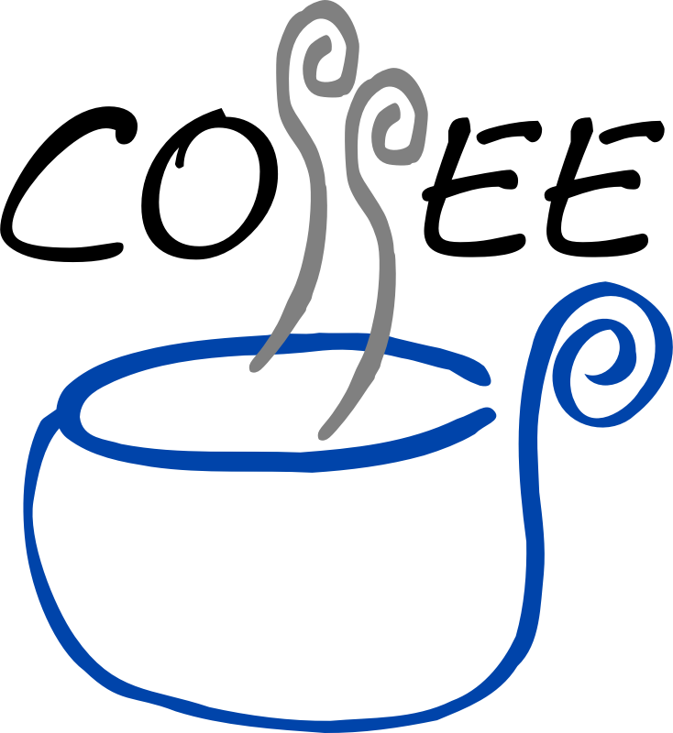  Thanks in advance to our members for their coffee or tea donations to  our club! | 1  COPC Open Pairs  A/B/C 9:15  Gentle Duplicate  A/B/C 12:45 | 2 Practice Play 9:30  COPC Open Pairs A/B/C 12:30  0-300 Strat Pairs A/B/C 6:30 | 3  COPC Open Pairs  A/B/C 10:30-2:00  COPC Open Pairs  A/B/C 7 pm | 4 0-99ers 9:30-11:30  October 2018 - HALIFAX BRIDGE WORLD – Celebrating 37 great years! 902-454-4098  0-2000 Strat Pairs  A/B/C 12:30  COPC Where’s Waldo Open Pairs A/B/C 7pm | 5 ACBL Senior Pairs  Strat A/B/C 9:15 am  0-500 Strat Pairs  A/B/C 12:45 | 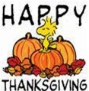  COPC Open Pairs A/B/C 12:30
 | 8  COPC Open Pairs  A/B/C 9:15  Gentle Duplicate  A/B/C 12:45 | 9 Practice Play 9:30  COPC Open Pairs A/B/C 12:30  0-300 Strat Pairs A/B/C 6:30 | 10  C/A Open Pairs  A/B/C 10:30-2:00  COPC Open Pairs  A/B/C 7 pm | 11 0-99ers 9:30-11:30  Canada Olympiad Fund Game 12:30  COPC Where’s Waldo Open Pairs A/B/C 7pm | 12  C/A Open Pairs A/B/C 9:15  0-500 Strat Pairs  A/B/C 12:45 | 13  COPC Open Pairs A/B/C 12:30  COPC Open Pairs A/B/C 12:30
14  0-2000  Team Game  12:30 | 15  C/A Open Pairs  A/B/C 9:15  Gentle Duplicate  A/B/C 12:45 | 16 Practice Play 9:30  COPC Open Pairs A/B/C 12:30  C/A 0-300 Strat Pairs A/B/C 6:30 | 17  COPC Open Pairs  A/B/C 10:30-2:00  COPC Open Pairs  A/B/C 7 pm | 18 0-99ers 9:30-11:30  0-2000 Strat Pairs  A/B/C 12:30  COPC Where’s Waldo Open Pairs A/B/C 7pm | 19 Open Strat Pairs 9:15  0-500 Strat Pairs 12:45  AGM 2018 6:15 pm  FREE C/A game for Members @ 7 pm | 20  37th Anniversary!  Club Appreciation A/B/C Pairs game  12:30 pm
21  37th Anniversary 12:30  Strati-Flighted A/X and B/C/D Team Game  Dusting of GOLD! | 22  COPC Open Pairs  A/B/C 9:15  Gentle Duplicate  C/A A/B/C 12:45 | 23 Practice Play 9:30  COPC Open Pairs A/B/C 12:30  0-300 Strat Pairs A/B/C 6:30 | 24  COPC Open Pairs  A/B/C 10:30-2:00  COPC Open Pairs  A/B/C 7 pm | 25 0-99ers 9:30-11:30  Erin Berry Rookie/Master Game 12:30  COPC Where’s Waldo Open Pairs A/B/C 7pm  HBW celebrating its 37th Anniversary! The festivities begin with our 2018 AGM on Friday Oct 19th at 6:15 pm. All members are encouraged to attend. A FREE Club Appreciation Pairs game to follow at 7pm and a C/A pairs game on Saturday for everyone! Come fill the club and we will strati-flight the game for A/X and B/C/D players! On Sunday we will host a Strati-flighted Team game for all. Food, fun and prizes! Saturday and Sunday games are $10 per player.  C/A = Club Appreciation games 3x the points!  COPC = Red/Black points! | 26  COPC Open Pairs A/B/C 9:15  0-500 Strat Pairs  A/B/C 12:45 | 27  Happy Birthday &  COPC Open Pairs A/B/C 12:30
28  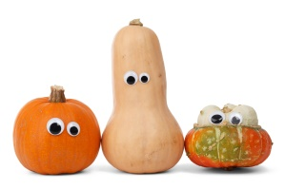 | 29  COPC Open Pairs  A/B/C 9:15  Gentle Duplicate  A/B/C 12:45 | 30 Practice Play 9:30  C/A Open Pairs A/B/C A/B/C/ 12:30  0-300 Strat Pairs A/B/C 6:30 | 31 INSTANT Matchpoint Game  Gold A/B/C 12:30  C/A Open Pairs  A/B/C 7 pm

